

**School of Computer Science and Engineering**

**J Component report**

**Programme : M.Tech(Software Engineering)**

**Course Title : DATA MINING**

**Course Code : SWE2009**

**Slot : B2+TB2**

**Title: Brain Tumor Detection using MRI images with the help of CNN**

**Team Members: Adithya S.T.| 18MIS1025**

**Medha S | 18MIS1060**

**Faculty:** Dr. Hema N  **Sign:**

**Date:**



**SCHOOL OF COMPUTER SCIENCE AND ENGINEERING**

**DECLARATION**

I hereby declare that the project entitled Brain Tumor Detection using MRI images submitted by us to the School of Computer Science and Engineering, Vellore Institute of Technology - Chennai Campus, 600 127. In fulfillment of the requirements of the award of the course of SWE2009 – Data Mining Techniques is a bona-fide record of the work carried out by us under the supervision of Dr. Hema N. I further declare that the work reported in this project, has not been submitted and will not be submitted, either in part or in full, for the award of any other degree or diploma of this institute or of any other institute or University.

Place: Chennai Signature of the student

Date:07-12-2021



**CERTIFICATE**

This is to certify that the report entitled Brain Tumor Detection using MRI images prepared and submitted by Medha S – 18MIS1060 and Adithya S T - 18MIS1025 to Vellore Institute of Technology - Chennai Campus, In fulfillment of the requirements of the award of the course SWE2009 – Data Mining Techniques is a Bonafide record carried out under my guidance. The project fulfils the requirements as per the regulations of this University and in my opinion, meets the necessary standards for submission. The contents of this report have not been submitted and will not be submitted either in part or in full, for the award of any other degree or diploma and the same is Certificate.



**ACKNOWLEDGEMENT**

We are profoundly grateful to Dr Hema N for his expert guidance and continuous encouragement throughout to see that this project rights its target from its commencement to its completion.

We would like to express our deepest appreciation towards Vellore Institute Of Technology Chennai and Dr Asnath Phamila Y, Head of the Department of Software Engineering whose invaluable guidance supported us in completing this project.

At last, we must express our sincere heartfelt gratitude to our friends and seniors who helped me directly or indirectly during this course of work.

Place: Chennai Signature of the Professor

Date:07-12-2021

Medha S – 18MIS1060

Adithya S T – 18MIS1025

**CONTENTS**

|  |  |  |
| --- | --- | --- |
| **Chapter** | **Title** | **Page** |
|  |  |  |
|  | Title Page | i |
|  | Declaration | ii |
|  | Certificate | iii |
|  |  |  |
|  | Acknowledgement | iv |
|  | Table of contents | v |
|  | List of Figures | vi |
|  |  |  |
|  | Abstract | 01 |
|  |  |  |
|  |  |  |
| 1 | Introduction | 01 |
| 2 | Literature Review | 02 |
| 3 | Method | 03 |
| 4 | Result and Discussion | 07 |
| 5 | Conclusion | 08 |
|  | References | 08 |
|  |  |  |

**LIST OF FIGURES**

**Title Page**

**Fig 1:** CNN Diagram  02

**Fig 2:** Samples of the dataset  03

**Fig 3:** Proposed Method Diagram 04

**Abstract.** Magnetic resonance imaging (MRI) is the imaging technique used to diagnosing brain tumor disease. Early diagnosis of brain tumors is an essential task in medical work to find out whether the tumor can potentially become cancerous. Deep learning is a handy and efficient method for image classification. Deep learning has been widely applied in various fields including medical imaging, because its application does not require the reliability of an expert in the related field, but requires the amount of data and diverse data to produce good classification results. Convolutional Neural Network (CNN) is the deep learning technique to perform image classification. In this paper, we compared two model CNN find the best model CNN to classify tumours in Brain MRI Image and at the end, we have trained CNN and obtained a prediction accuracy of up to 93%.

## Introduction

According to the Indonesian Ministry of Health, in 2018 Indonesia became the number of 8th cancer patient in Southeast Asia and ranked 23rd in Asia[1]. Brain tumors are the second cause of death in cancer cases after breast cancer. From all cases, it is known that women are more affected by brain tumors than men. Brain tumors have continued to increase in incidence for a decade last in several countries [2]. Medical imaging is key in diagnosing brain tumors and can help prevent more virulent diseases. MRI is imaging techniques that researchers rely on to detect brain tumors[3]. MRI is one of the most widely used medical imaging techniques for brain tumors because it does not use ionizing radiation [4].

There are many studies about the detection of brain tumors, Parveen et al. [5], using a combination of Fuzzy C-Means and SVM methods. In this study, using Fuzzy C-Means to segment between parts of the brain and the parts indicated to have tumors, the use of Fuzzy C-Means in this paper shows good results. After segmentation, the Gray Level Run-Length Matrix (GLRLM) is used to feature extraction. The purpose of feature extraction is to find relevant features of an image to facilitate the classification process. The classification technique used in the method is SVM. In the method used, the accuracy achieved was 83.33%.

Avizenna et al. [6] using the fluid-attenuated inversion recovery (FLAIR) method. This study proposed to classify MRI images into two classes, normal brains and abnormal brains. BRATS database data 2017 used in this study. Process classification brain MRI images using multinomial logistic regression models with ridge estimators, and scoring using sensitivity, specificity, accuracy with cross- fold validation.

However, in unsupervised method-based segmentation, as before the extraction feature is not obtained implicitly, there is a need for human touch [7]. Then, to segment the brain image there are still many obstacles, there are problems such as the shape or location that is different from each patient. According to Işin A et al [8], the devices used for scanning vary greatly so as to produce images that have different characteristics in the dataset.

In this paper, the CNN method is proposed to solve the problem of data complexity. CNN is able to extract features without removing the spatial information from the input data. CNN is a machine learning method to process two-dimensional data. CNN has two methods: classification using feedforward and learning using backpropagation.[7]. But apart from the advantages of CNN architecture, which is simple for users, but on the development process, CNN requires amount data for the learning process and consume a lot of learning time compared to unsupervised learning approaches. In this research, 2 CNN models were made as a comparison to find the best model for classification.

## Literature Review

* 1. *Convolutional Neural Network*

CNN is a neural network that aims to process data that has a grid structure. Convolution is an operation in convolution layer that is based on a linear algebra operation that multiplies matrix of the filter in the image to be processed [9]. The convolution layer is the primary layer that is most important to use. Another type of layer that is commonly used is the pooling layer, which is a layer that is used to take the maximum value or the average value of the pixel portions of the image.

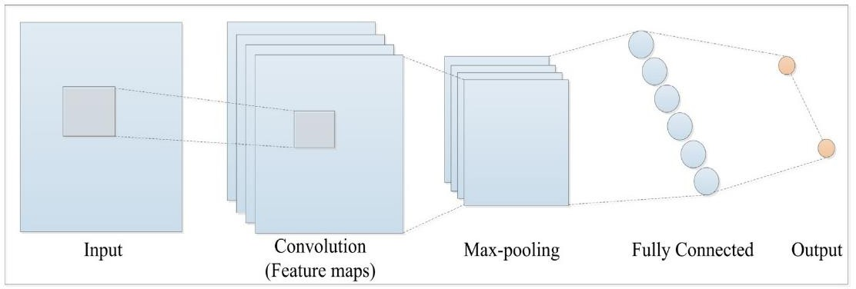CNN has the ability to learn complicated features by forming a feature map. The convolution layer kernel is wrapped around the input sample to calculate several feature maps. Features are detected from input samples than represented by small boxes on the feature map. These maps are forwarded to the maximum collection layer, which preserves relevant features and discards the rest. The features of the max-pooling layer are converted to a one-dimensional feature vector in the fully connected layer, which is then used to calculate the output probability. The configuration of CNN is shown in Figure 1[10].

**Figure 1.** CNN architecture [10]

* + 1. *Convolution Layer*

Convolution Layer is the core layer in the CNN method which aims to extract features from the input. Convolution performs linear transformations of input data without changing spatial information in the data. Convolution kernels are determined from the weight of the layer so that the convolution kernels can process the input data training on CNN.

* + 1. *Subsampling Layer*

Subsampling aims to reduce the size of image data and to increase the invariance of feature positions. CNN uses Max Pooling as a subsampling method. The way Max Pooling works is to divide the output of the convolution layer into several smaller grids and then take the maximum value from each grid to produce a smaller image matrix. With a small image size will make it easier to process the next convolution layer.

* + 1. *Fully Connected Layer*

The Fully Connected Layer changes the dimensions of the data so that it can be classified linearly. In the convolution layer, each neuron must be transformed into one-dimensional data before being inserted into another layer that is connected as a whole[11]. This process is caused by data losing its spatial information and at the end of the Fully Connected Layer network is applied

## Method

* 1. *Dataset*

The dataset used in this study is Brain MRI Images for Brain Tumor Detection obtained from kaggle.com. The dataset consists of 253 images grouped into 2 groups, 155 brain images that have tumors, and 98 brain images that do not have tumors. Figure 2 shows images in the dataset.

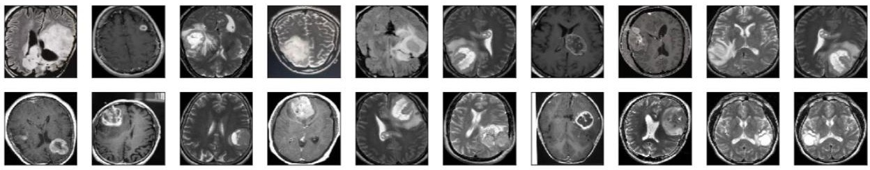

**Figure 2.** samples of the dataset

* 1. *Proposed Method*

This paper uses CNN for the automatic detection of brain tumors. This study uses input images labeled (yes/no) from the raw data and then uses these patterns to distinguish between tissues that do not contain tumors and those that contain tumors. CNN was trained to use 2065 sample images consisting of 1085 images containing tumors and 980 not containing tumors. Therefore, the proposed system is illustrated in Figure 3 method proposed in this study.

Feature

Raw Data

Augmentation

Data

Convolutional and Pooling Layer



Yes

Fully Connected Layer



No

**Figure 3.** Method proposed

**Yes** represents the **tumorous** class

**No** represents the **non-tumourous** class

* 1. *Data Augmentation*

The amount of data in the dataset is not enough to be used as training data for CNN. Therefore the augmentation method is used to overcome the imbalance of issues. Augmentation is an algorithm that can utilize statistical data information and form an integrated model. This algorithm can produce a number of two-dimensional images of various poses and sizes. The application of augmentation to obtain image variants can improve the accuracy of CNN segmentation[12]. In this paper, each image with a tumor is segmented into 6 images, and an image with no tumor is segmented into 9 images. After data augmentation, the dataset consists of 1085 samples containing tumors (53%) and 980 samples not containing tumors (47%), bringing a total of 2065 images.

* 1. *Image Pre-processing*

Pre-processing performs to create smooth training because there are different variants of intensity, contrast, and size in images [13]. Input image will be processed into the first pre-process that is the process of wrapping and cropping. In wrapping, the input image is checked against the edge of the main object in the image. From the edge of the image, the maximum edge is determined so that when the results of cropping, the object in the image remains intact. After cropping, resize the image to shape (240, 240, 3) = (image_width, image_height, number of channels) because the images in the dataset have different sizes. Apply normalization: to scale pixel values to the range 0-1 to facilitate the learning process.

*3.5 Model CNN*

In this research, the CNN model contains several layers, namely the convolution layer, the pooling layer, the flatten layer, the dropout layer, and the dense layer. In addition to the layers used in the CNN process, there is also an activation function in this study using rule activation. In this research, 2 CNN models were made as comparison material. The CNN model design can be seen in table 1 and table 2. An image in the form of a number interweaving the first convolution, image size of 240x240 pixels. Kernels that have a size of 3x3 with a thickness of 3 in accordance with the channel of the image data and filters are used as many as 32. After getting the results of the operation, the model will perform the activation and pooling data functions. The Pooling layer process serves to reduce the dimensions of the feature map. The result of the convolution process is a feature map that is used for the subsequent convolution process repeatedly. The next step is a fallen feature map in vector form to carry out a fully-connected layer process to produce a classification of images.

**Table 1.** First CNN model.

|  |  |  |
| --- | --- | --- |
| Layer (type) | Output Shape | Param # |
| conv2d (Conv2D) | (None, 240, 240, 32) | 896 |
| max_pooling2d (MaxPooling2D) | (None, 60, 60, 32) | 0 |
| max_pooling2d_1 (MaxPooling2D) | (None, 30, 30, 32) | 0 |
| max_pooling2d_2 (MaxPooling2D) | (None, 15, 15, 32) | 0 |
| flatten (Flatten) | (None, 7200) | 0 |
| dense (Dense) | (None, 256) | 1843456 |
| dense_1 (Dense) | (None, 1) | 257 |
| Total params: 1,844,609  Trainable params: 1,844,609  Non-trainable params: 0 |  |  |

**Table 2.** Second CNN model.

|  |  |  |
| --- | --- | --- |
| Layer (type) | Output Shape | Param # |
| conv0 (Conv2D) | (None, 240, 240, 32) | 896 |
| max_pooling2d (MaxPooling2D) | (None, 60, 60, 32) | 0 |
| dropout (Dropout) | (None, 60, 60, 32) | 0 |
| conv2d_1 (Conv2D) | (None, 60, 60, 32) | 9248 |
| max_pooling2d_1 (MaxPooling2D) | (None, 15, 15, 32) | 0 |
| dropout_1 (Dropout) | (None, 15, 15, 32) | 0 |
| flatten (Flatten) | (None, 7200) | 0 |
| dense (Dense) | (None, 256) | 1843456 |
| dropout_3 (Dropout) | (None, 256) | 0 |
| dense_1 (Dense) | (None, 1) | 257 |
| Total params: 1,863,105  Trainable params: 1,863,105  Non-trainable params: 0 |  |  |

1. **Source Code & Output:**

import tensorflow as tf

from tensorflow.keras.layers import Conv2D, Input, ZeroPadding2D, BatchNormalization, Activation, MaxPooling2D, Flatten, Dense

from tensorflow.keras.models import Model, load_model

from tensorflow.keras.callbacks import TensorBoard, ModelCheckpoint

from sklearn.model_selection import train_test_split

from sklearn.metrics import f1_score

from sklearn.utils import shuffle

import cv2

import imutils

import numpy as np

import matplotlib.pyplot as plt

import time

from os import listdir

%matplotlib inline

## Data Preparation & Preprocessing

In order to crop the part that contains only the brain of the image, I used a cropping technique to find the extreme top, bottom, left and right points of the brain.

def crop_brain_contour(image, plot=False):

    #import imutils

    #import cv2

    #from matplotlib import pyplot as plt

    # Convert the image to grayscale, and blur it slightly

    gray = cv2.cvtColor(image, cv2.COLOR_BGR2GRAY)

    gray = cv2.GaussianBlur(gray, (5, 5), 0)

    # Threshold the image, then perform a series of erosions +

    # dilations to remove any small regions of noise

    thresh = cv2.threshold(gray, 45, 255, cv2.THRESH_BINARY)[1]

    thresh = cv2.erode(thresh, None, iterations=2)

    thresh = cv2.dilate(thresh, None, iterations=2)

    # Find contours in thresholded image, then grab the largest one

    cnts = cv2.findContours(thresh.copy(), cv2.RETR_EXTERNAL, cv2.CHAIN_APPROX_SIMPLE)

    cnts = imutils.grab_contours(cnts)

    c = max(cnts, key=cv2.contourArea)

    # Find the extreme points

    extLeft = tuple(c[c[:, :, 0].argmin()][0])

    extRight = tuple(c[c[:, :, 0].argmax()][0])

    extTop = tuple(c[c[:, :, 1].argmin()][0])

    extBot = tuple(c[c[:, :, 1].argmax()][0])

    # crop new image out of the original image using the four extreme points (left, right, top, bottom)

    new_image = image[extTop[1]:extBot[1], extLeft[0]:extRight[0]]

    if plot:

        plt.figure()

        plt.subplot(1, 2, 1)

        plt.imshow(image)

        plt.tick_params(axis='both', which='both',

                        top=False, bottom=False, left=False, right=False,

                        labelbottom=False, labeltop=False, labelleft=False, labelright=False)

        plt.title('Original Image')

        plt.subplot(1, 2, 2)

        plt.imshow(new_image)

        plt.tick_params(axis='both', which='both',

                        top=False, bottom=False, left=False, right=False,

                        labelbottom=False, labeltop=False, labelleft=False, labelright=False)

        plt.title('Cropped Image')

        plt.show()

    return new_image

In order to better understand what it's doing, let's grab an image from the dataset and apply this cropping function to see the result:

In order to better understand what it's doing, let's grab an image from the dataset and apply this cropping function to see the result:\

**Output:**

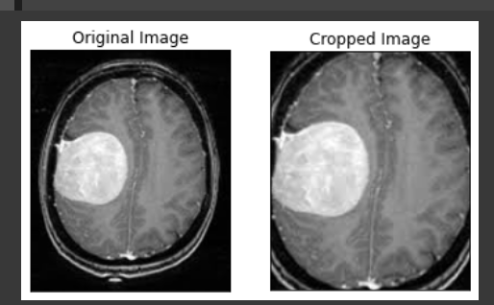

**Load up the data:**

The following function takes two arguments, the first one is a list of directory paths for the folders 'yes' and 'no' that contain the image data and the second argument is the image size, and for every image in both directories and does the following:

1. Read the image.

2. Crop the part of the image representing only the brain.

3. Resize the image (because the images in the dataset come in different sizes (meaning width, height and # of channels). So, we want all of our images to be (240, 240, 3) to feed it as an input to the neural network.

4. Apply normalization because we want pixel values to be scaled to the range 0-1.

5. Append the image to X and its label to y

After that, Shuffle X and y, because the data is ordered (meaning the arrays contains the first part belonging to one class and the second part belonging to the other class, and we don't want that).

Finally, Return X and y.

def load_data(dir_list, image_size):

    """

    Read images, resize and normalize them.

    Arguments:

        dir_list: list of strings representing file directories.

    Returns:

        X: A numpy array with shape = (#_examples, image_width, image_height, #_channels)

        y: A numpy array with shape = (#_examples, 1)

    """

    # load all images in a directory

    X = []

    y = []

    image_width, image_height = image_size

    for directory in dir_list:

        for filename in listdir(directory):

            # load the image

            image = cv2.imread(directory + '//' + filename)

            # crop the brain and ignore the unnecessary rest part of the image

            image = crop_brain_contour(image, plot=False)

            # resize image

            image = cv2.resize(image, dsize=(image_width, image_height), interpolation=cv2.INTER_CUBIC)

            # normalize values

            image = image / 255.

            # convert image to numpy array and append it to X

            X.append(image)

            # append a value of 1 to the target array if the image

            # is in the folder named 'yes', otherwise append 0.

            if directory[-3:] == 'yes':

                y.append([1])

            else:

                y.append([0])

    X = np.array(X)

    y = np.array(y)

    # Shuffle the data

    X, y = shuffle(X, y)

    print(f'Number of examples is: {len(X)}')

    print(f'X shape is: {X.shape}')

    print(f'y shape is: {y.shape}')

    return X, y

Load up the data that we augmented earlier in the Data Augmentation notebook.  
**Note:** the augmented data directory contains not only the new generated images but also the original images.

augmented_path = '/content/drive/MyDrive/Brain-Tumor-Detection-master/augmenteddata/'

# augmented data (yes and no) contains both the original and the new generated examples

augmented_yes = augmented_path + 'yes'

augmented_no = augmented_path + 'no'

IMG_WIDTH, IMG_HEIGHT = (240, 240)

X, y = load_data([augmented_yes, augmented_no], (IMG_WIDTH, IMG_HEIGHT))

**Output:**

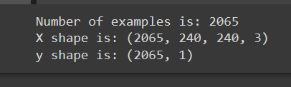

**Plot sample images:**

def plot_sample_images(X, y, n=50):

    """

    Plots n sample images for both values of y (labels).

    Arguments:

        X: A numpy array with shape = (#_examples, image_width, image_height, #_channels)

        y: A numpy array with shape = (#_examples, 1)

    """

    for label in [0,1]:

        # grab the first n images with the corresponding y values equal to label

        images = X[np.argwhere(y == label)]

        n_images = images[:n]

        columns_n = 10

        rows_n = int(n/ columns_n)

        plt.figure(figsize=(20, 10))

        i = 1 # current plot

        for image in n_images:

            plt.subplot(rows_n, columns_n, i)

            plt.imshow(image[0])

            # remove ticks

            plt.tick_params(axis='both', which='both',

                            top=False, bottom=False, left=False, right=False,

                           labelbottom=False, labeltop=False, labelleft=False, labelright=False)

            i += 1

        label_to_str = lambda label: "Yes" if label == 1 else "No"

        plt.suptitle(f"Brain Tumor: {label_to_str(label)}")

        plt.show()

plot_sample_images(X, y)

**Output:**

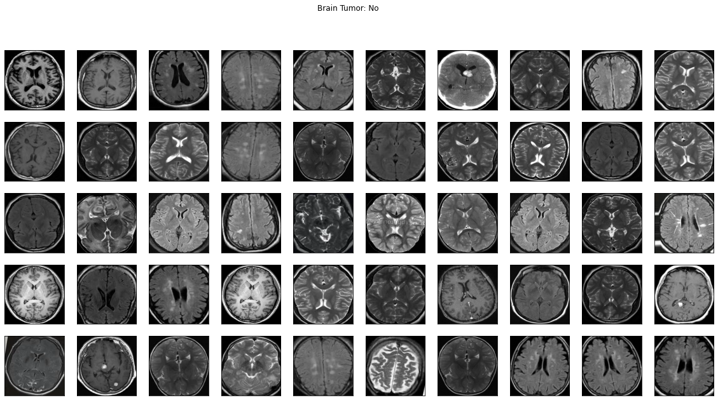

**Split the data:**

**Split X and y into training, validation (development) and validation sets.**

**Code:**

def split_data(X, y, test_size=0.2):

    """

    Splits data into training, development and test sets.

    Arguments:

        X: A numpy array with shape = (#_examples, image_width, image_height, #_channels)

        y: A numpy array with shape = (#_examples, 1)

    Returns:

        X_train: A numpy array with shape = (#_train_examples, image_width, image_height, #_channels)

        y_train: A numpy array with shape = (#_train_examples, 1)

        X_val: A numpy array with shape = (#_val_examples, image_width, image_height, #_channels)

        y_val: A numpy array with shape = (#_val_examples, 1)

        X_test: A numpy array with shape = (#_test_examples, image_width, image_height, #_channels)

        y_test: A numpy array with shape = (#_test_examples, 1)

    """

    X_train, X_test_val, y_train, y_test_val = train_test_split(X, y, test_size=test_size)

    X_test, X_val, y_test, y_val = train_test_split(X_test_val, y_test_val, test_size=0.5)

    return X_train, y_train, X_val, y_val, X_test, y_test

Let's use the following way to split:

1. 70% of the data for training.
2. 15% of the data for validation.
3. 15% of the data for testing.
4. X_train, y_train, X_val, y_val, X_test, y_test = split_data(X, y, test_size=0.3)
5. print ("number of training examples = " + str(X_train.shape[0]))
6. print ("number of development examples = " + str(X_val.shape[0]))
7. print ("number of test examples = " + str(X_test.shape[0]))
8. print ("X_train shape: " + str(X_train.shape))
9. print ("Y_train shape: " + str(y_train.shape))
10. print ("X_val (dev) shape: " + str(X_val.shape))
11. print ("Y_val (dev) shape: " + str(y_val.shape))
12. print ("X_test shape: " + str(X_test.shape))
13. print ("Y_test shape: " + str(y_test.shape))

Some helper functions:

# Nicely formatted time string

def hms_string(sec_elapsed):

    h = int(sec_elapsed / (60 * 60))

    m = int((sec_elapsed % (60 * 60)) / 60)

    s = sec_elapsed % 60

    return f"{h}:{m}:{round(s,1)}"

def compute_f1_score(y_true, prob):

    # convert the vector of probabilities to a target vector

    y_pred = np.where(prob > 0.5, 1, 0)

    score = f1_score(y_true, y_pred)

    return score

**Build the Model:**

def build_model(input_shape):

    """

    Arugments:

        input_shape: A tuple representing the shape of the input of the model. shape=(image_width, image_height, #_channels)

    Returns:

        model: A Model object.

    """

    # Define the input placeholder as a tensor with shape input_shape.

    X_input = Input(input_shape) # shape=(?, 240, 240, 3)

    # Zero-Padding: pads the border of X_input with zeroes

    X = ZeroPadding2D((2, 2))(X_input) # shape=(?, 244, 244, 3)

    # CONV -> BN -> RELU Block applied to X

    X = Conv2D(32, (7, 7), strides = (1, 1), name = 'conv0')(X)

    X = BatchNormalization(axis = 3, name = 'bn0')(X)

    X = Activation('relu')(X) # shape=(?, 238, 238, 32)

    # MAXPOOL

    X = MaxPooling2D((4, 4), name='max_pool0')(X) # shape=(?, 59, 59, 32)

    # MAXPOOL

    X = MaxPooling2D((4, 4), name='max_pool1')(X) # shape=(?, 14, 14, 32)

    # FLATTEN X

    X = Flatten()(X) # shape=(?, 6272)

    # FULLYCONNECTED

    X = Dense(1, activation='sigmoid', name='fc')(X) # shape=(?, 1)

    # Create model. This creates your Keras model instance, you'll use this instance to train/test the model.

    model = Model(inputs = X_input, outputs = X, name='BrainDetectionModel')

    return model

**Define the image shape:**

IMG_SHAPE = (IMG_WIDTH, IMG_HEIGHT, 3)

model = build_model(IMG_SHAPE)

model.summary()

**Output:**

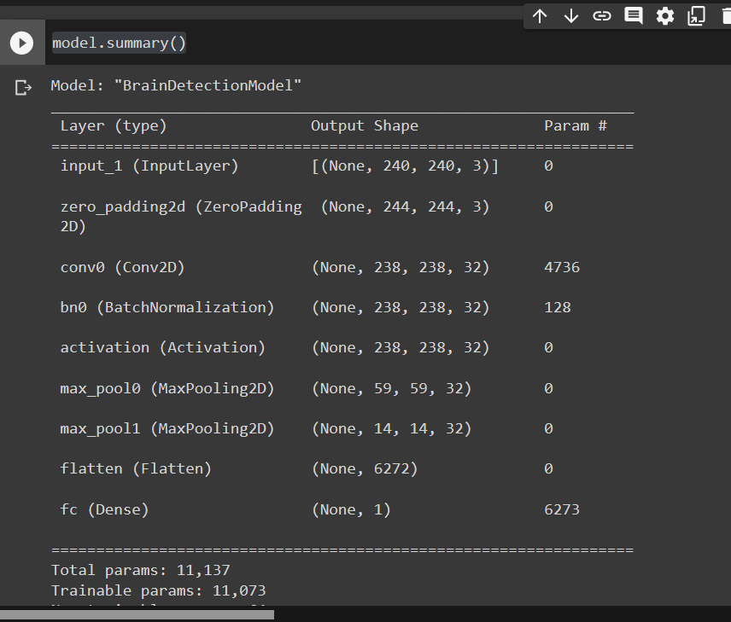

**Compile the model:**

model.compile(optimizer='adam', loss='binary_crossentropy', metrics=['accuracy'])

# tensorboard

log_file_name = f'brain_tumor_detection_cnn_{int(time.time())}'

tensorboard = TensorBoard(log_dir=f'logs/{log_file_name}')

# checkpoint

# unique file name that will include the epoch and the validation (development) accuracy

filepath="cnn-parameters-improvement-{epoch:02d}-{val_accuracy:.2f}"

# save the model with the best validation (development) accuracy till now

checkpoint = ModelCheckpoint("models/{}.model".format(filepath, monitor='val_accuracy', verbose=1, save_best_only=True, mode='max'))

import torch, gc

gc.collect()

torch.cuda.empty_cache()

# Garbage Collector - use it like gc.collect()

import gc

# Custom Callback To Include in Callbacks List At Training Time

class GarbageCollectorCallback(tf.keras.callbacks.Callback):

    def on_epoch_end(self, epoch, logs=None):

        gc.collect()

gc.collect()

## Train the model:

start_time = time.time()

model.fit(x=X_train, y=y_train, batch_size=32, epochs=10, validation_data=(X_val, y_val), callbacks=[tensorboard, checkpoint])

end_time = time.time()

execution_time = (end_time - start_time)

print(f"Elapsed time: {hms_string(execution_time)}")

**Output:**

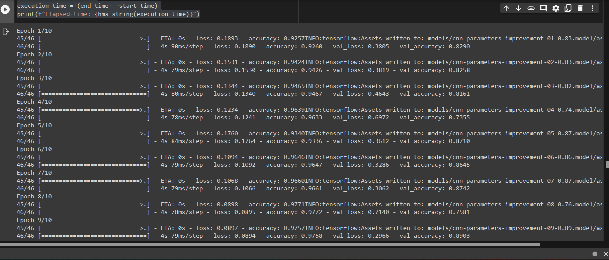

**Let's train for a few more epochs:**

start_time = time.time()

model.fit(x=X_train, y=y_train, batch_size=32, epochs=3, validation_data=(X_val, y_val), callbacks=[tensorboard, checkpoint])

end_time = time.time()

execution_time = (end_time - start_time)

print(f"Elapsed time: {hms_string(execution_time)}")

**Output:**

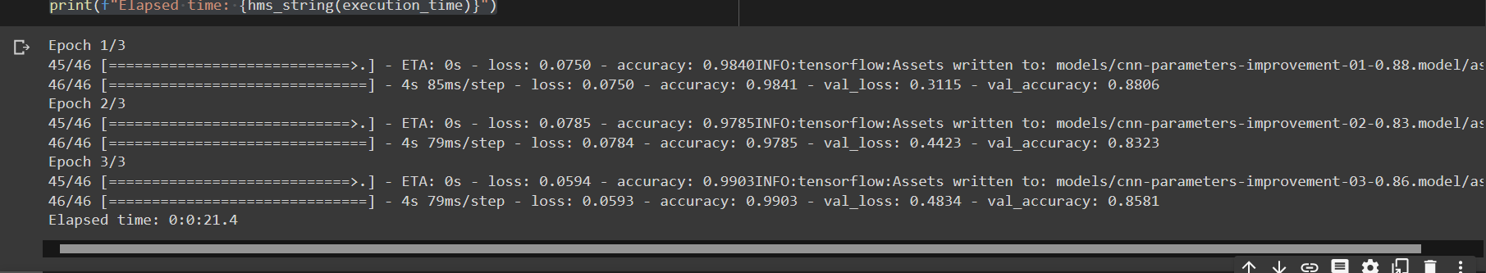

start_time = time.time()

model.fit(x=X_train, y=y_train, batch_size=32, epochs=3, validation_data=(X_val, y_val), callbacks=[tensorboard, checkpoint])

end_time = time.time()

execution_time = (end_time - start_time)

print(f"Elapsed time: {hms_string(execution_time)}")

**Output:**

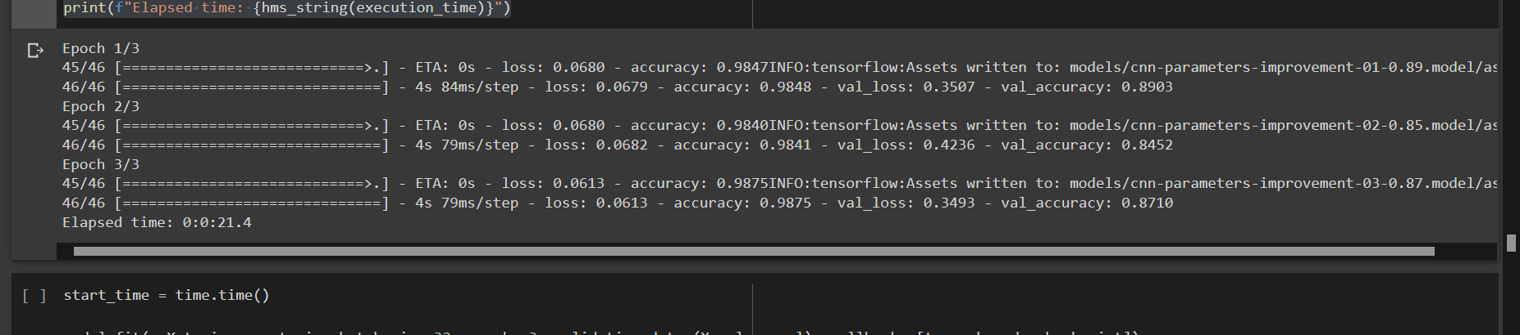

start_time = time.time()

model.fit(x=X_train, y=y_train, batch_size=32, epochs=3, validation_data=(X_val, y_val), callbacks=[tensorboard, checkpoint])

end_time = time.time()

execution_time = (end_time - start_time)

print(f"Elapsed time: {hms_string(execution_time)}")

**Output:**

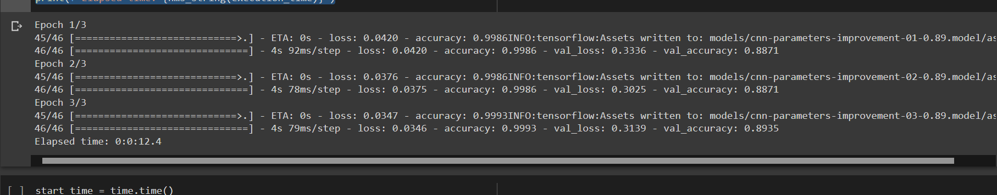

start_time = time.time()

model.fit(x=X_train, y=y_train, batch_size=32, epochs=5, validation_data=(X_val, y_val), callbacks=[tensorboard, checkpoint])

end_time = time.time()

execution_time = (end_time - start_time)

print(f"Elapsed time: {hms_string(execution_time)}")

**Output:**

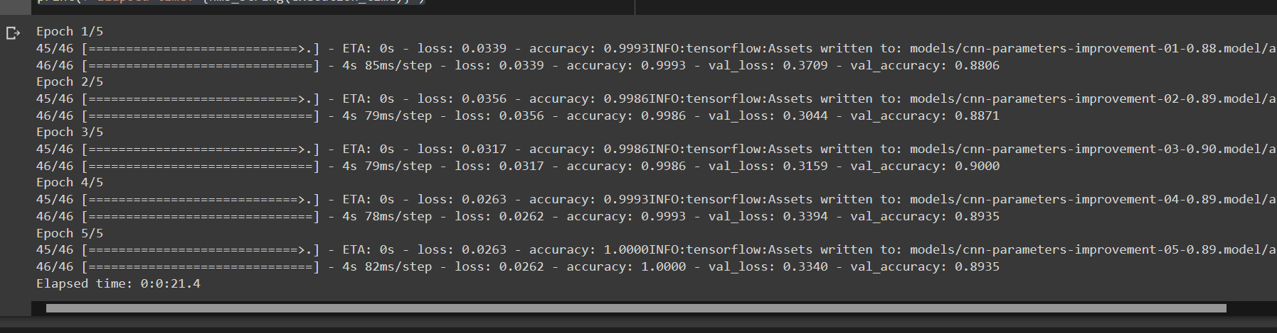

history = model.history.history

for key in history.keys():

    print(key)

**Output:**

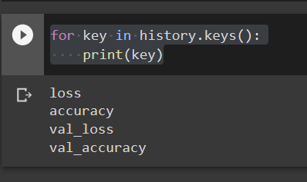

## Plot Loss & Accuracy

def plot_metrics(history):

    train_loss = history['loss']

    val_loss = history['val_loss']

    train_acc = history['accuracy']

    val_acc = history['val_accuracy']

    # Loss

    plt.figure()

    plt.plot(train_loss, label='Training Loss')

    plt.plot(val_loss, label='Validation Loss')

    plt.title('Loss')

    plt.legend()

    plt.show()

    # Accuracy

    plt.figure()

    plt.plot(train_acc, label='Training Accuracy')

    plt.plot(val_acc, label='Validation Accuracy')

    plt.title('Accuracy')

    plt.legend()

    plt.show()

plot_metrics(history)

**Output:**

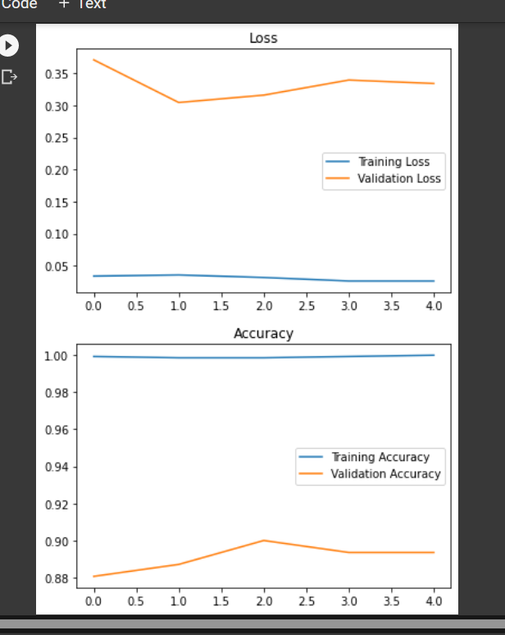

# Results

### **Load the best model**

best_model = load_model(filepath='/content/drive/MyDrive/Brain-Tumor-Detection-master/models/cnn-parameters-improvement-23-0.91.model')

best_model.metrics_names

**Output:**

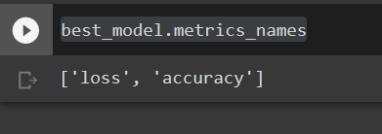

**Evaluate the best model on the testing data:**

loss, acc = best_model.evaluate(x=X_test, y=y_test)

**Accuracy of the best model on the testing data:**

print (f"Test Loss = {loss}")

print (f"Test Accuracy = {acc}")

**Output:**

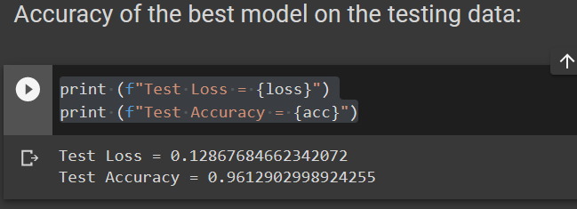

### **F1 score for the best model on the testing data:**

y_test_prob = best_model.predict(X_test)

f1score = compute_f1_score(y_test, y_test_prob)

print(f"F1 score: {f1score}")

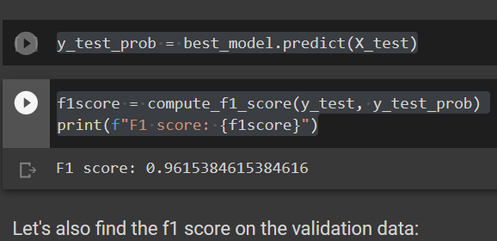

**Let's also find the f1 score on the validation data:**

y_val_prob = best_model.predict(X_val)

f1score_val = compute_f1_score(y_val, y_val_prob)

print(f"F1 score: {f1score_val}")

**Output:**

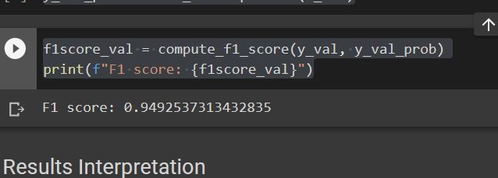

**Let's remember the percentage of positive and negative examples:**def data_percentage(y):

    m=len(y)

    n_positive = np.sum(y)

    n_negative = m - n_positive

    pos_prec = (n_positive* 100.0)/ m

    neg_prec = (n_negative* 100.0)/ m

    print(f"Number of examples: {m}")

    print(f"Percentage of positive examples: {pos_prec}%, number of pos examples: {n_positive}")

    print(f"Percentage of negative examples: {neg_prec}%, number of neg examples: {n_negative}")

# the whole data

data_percentage(y)

**Output:**

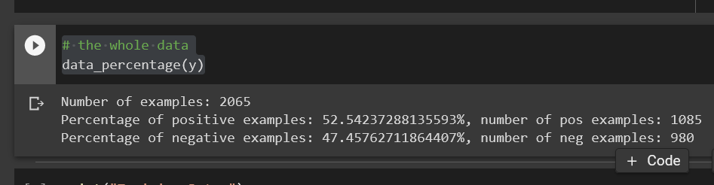

print("Training Data:")

data_percentage(y_train)

print("Validation Data:")

data_percentage(y_val)

print("Testing Data:")

data_percentage(y_test)

**Output:**

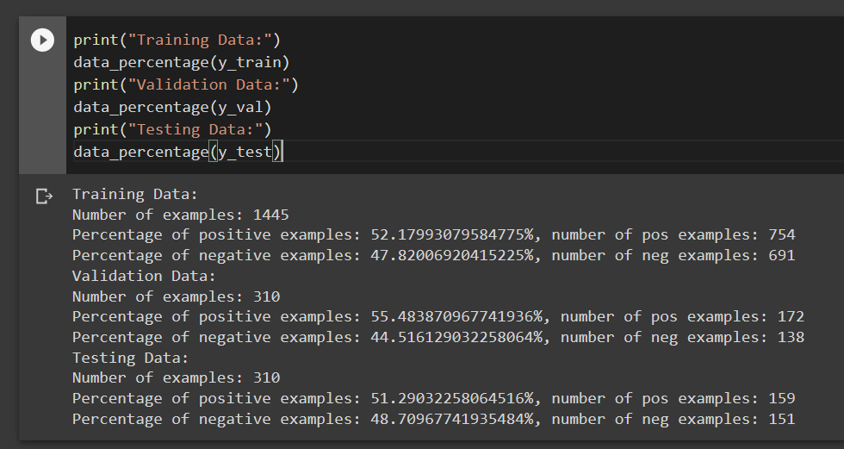

As expectred, the percentage of positive examples are around 50%.

# **Conclusion:**

#### **Now, the model detects brain tumor with:**

**88.7%** accuracy on the **test set**.  
**0.88** f1 score on the **test set**.  
These results are very good considering that the data is balanced.

**Output:**

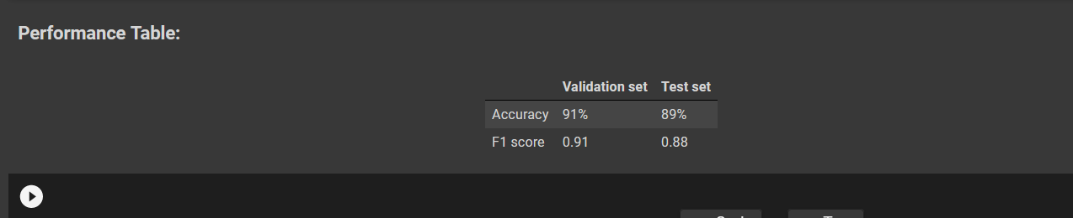

1. **Sample of Datasets:**

**Sample of Brain Tumor Images having value-“Yes”**

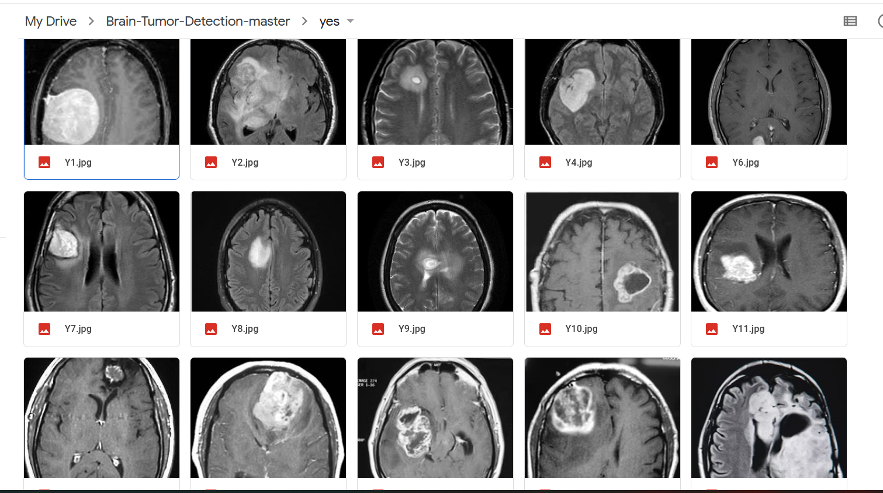

**Sample of Brain Tumor Images having value-“No”**

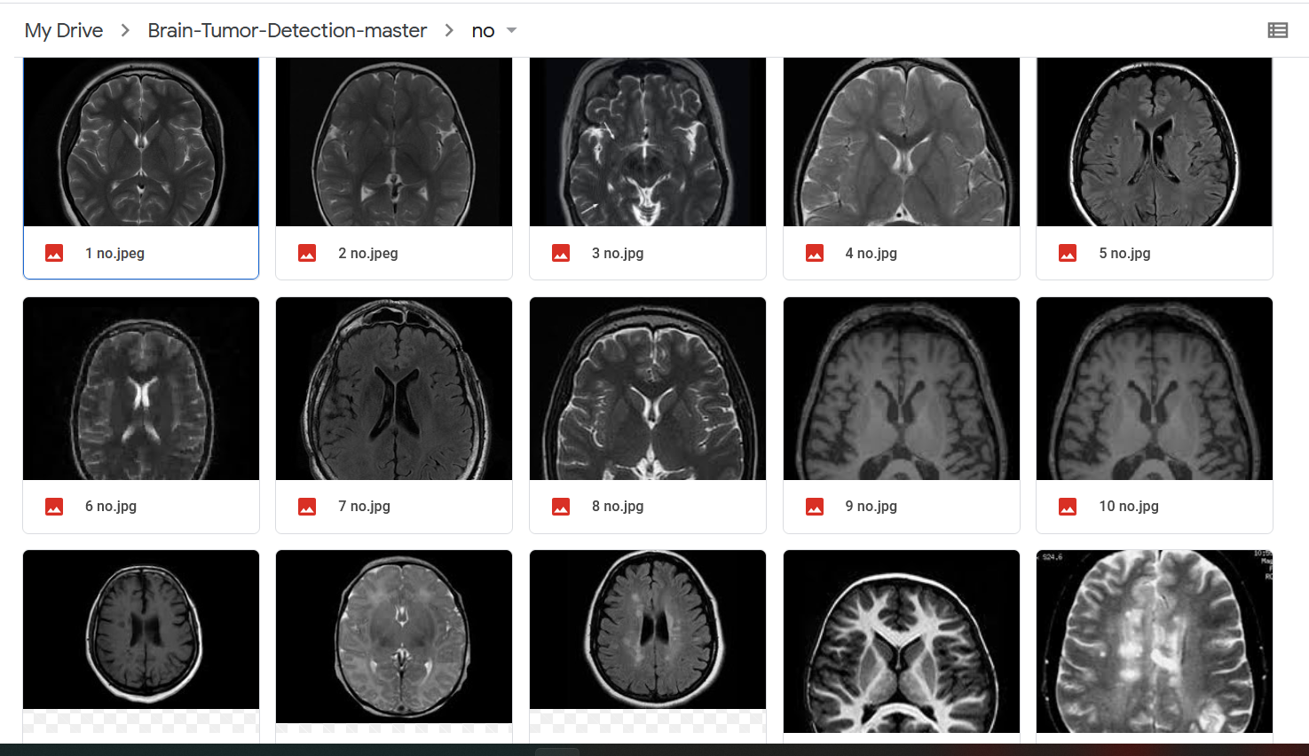

## Result and Discussion

Experiments in this article were carried out on 2065 images consisting of 1085 samples containing tumors and 980 samples containing no tumors. The data is further divided into 70% of the data as data training, 15% of the data as data validation, 15% of the data as data testing. The data is run 10 times, each using the CNN model that has been made before, each experiment using 25 epochs and 32 batches. The results are then compared using standard deviations, the mean and mean of the loss, accuracy and f1 score. In table 3 and table 4 can be seen from the results of the experiments conducted in this study. In the first CNN model, 1 convolution is used, and the average accuracy value is 94% and has an average loss value of 0.14181 on the training data, but there is a significant difference with the test data results, the average test data accuracy value is 85% and an average loss value of 0.44037. In the second CNN model using 2 convolution gets better results, the training data obtained an accuracy value of 96% and a loss value of 0.10046, then the test data obtained an accuracy value of 93% and a loss value of 0.23264. The f1 score on the second model is 92% but has a longer training time compared to the first model.

**Table 3.** Result of First CNN Model

No Train Val Test

|  |  |  |  |  |  |  |  |  |
| --- | --- | --- | --- | --- | --- | --- | --- | --- |
| 1 | Time Training  00:01:30 | Loss  0,1895 | Acc  0,9343 | Loss  0,3797 | Acc  0,8452 | Loss  0,3938 | Acc  0,8645 | f1  0,8742 |
| 2 | 00:01:31 | 0,1159 | 0,9592 | 0,3751 | 0,8774 | 0,4381 | 0,8483 | 0,8458 |
| 3 | 00:01:29 | 0,1793 | 0,9349 | 0,3908 | 0,8323 | 0,4013 | 0,8581 | 0,8682 |
| . | . | . | . | . | . | . | . | . |
| . | . | . | . | . | . | . | . | . |
| 8 | 00:01:29 | 0,0259 | 0,9722 | 0,3674 | 0,8903 | 0,5348 | 0,8709 | 0,8802 |
| 9 | 00:01:26 | 0,1221 | 0,9619 | 0,3762 | 0,8581 | 0,4632 | 0,8387 | 0,8538 |
| 10 | 00:01:26 | 0,2707 | 0,9183 | 0,3961 | 0,8355 | 0,4405 | 0,8322 | 0,8479 |
| Averae | 00:01:29 | 0,14181 | 0,9496 | 0,38254 | 0,85452 | 0,44037 | 0,85098 | 0,86048 |
| Mean | 00:01:29 | 0,14215 | 0,946 | 0,37795 | 0,8532 | 0,4293 | 0,8502 | 0,8575 |
| STD | 1,95511e-05 | 0,07132 | 0,0225 | 0,01134 | 0,02188 | 0,04233 | 0,01175 | 0,01119 |

**Table 4.** Result of Second CNN Model

|  |  |  |  |  |  |  |  |  |
| --- | --- | --- | --- | --- | --- | --- | --- | --- |
| No | Train | |  | Val |  |  | Test |  |
| Time Training | | Loss | Acc | Loss | Acc | Loss | Acc | f1 |
| 1 | 00:01:40 | 0,1625 | 0,9329 | 0,2765 | 0,9065 | 0,2655 | 0,9193 | 0,9158 |
| 2 | 00:01:39 | 0,0455 | 0,9862 | 0,2245 | 0,9258 | 0,2272 | 0,9419 | 0,9415 |
| 3 | 00:01:40 | 0,1105 | 0,9585 | 0,2104 | 0,9129 | 0,2258 | 0,9322 | 0,9302 |
| . | . | . | . | . | . | . | . | . |
| . | . | . | . | . | . | . | . | . |
| 8 | 00:01:41 | 0,1123 | 0,9578 | 0,1959 | 0,9032 | 0,2532 | 0,9258 | 0,9225 |
| 9 | 00:01:45 | 0,0789 | 0,9744 | 0,1874 | 0,9355 | 0,2172 | 0,9354 | 0,9328 |
| 10 | 00:01:46 | 0,1215 | 0,9543 | 0,2156 | 0,9129 | 0,2412 | 0,9291 | 0,9256 |
| Average | 00:01:42 | 0,10046 | 0,96402 | 0,22538 | 0,91485 | 0,23264 | 0,93221 | 0,92996 |
| Mean | 00:01:42 | 0,09965 | 0,96435 | 0,2181 | 0,9129 | 0,2269 | 0,9338 | 0,9315 |
| STD | 2,7411e-05 | 0,03143 | 0,01506 | 0,0317 | 0,00988 | 0,01629 | 0,00625 | 0,00725 |

## Conclusion

Convolutional Neural Networks are good enough to diagnose brain tumors on MRI images. This study resulted in accuracy of 93% and a loss value of 0.23264. The number of convolution layers affects the quality of classification, more convolution layers increase the accuracy results, but more number of convolution layers will require more time for training. The process of image augmentation can improve the variants of existing datasets, thereby increasing the classification results. Finally, for future suggestions, more images can be used to improve classification results. Future studies can also classify certain types of tumors.

## 

## References

1. “Penyakit Kanker di Indonesia Berada Pada Urutan 8 di Asia Tenggara dan Urutan 23 di Asia.” [Online]. Available: <http://p2p.kemkes.go.id/penyakit-kanker-di-indonesia-berada-pada-> urutan-8-di-asia-tenggara-dan-urutan-23-di-asia/.
2. S. EDY, W. I, and W. A, “Clinical Characteristics and Histopathology of Brain Tumor at Two Hospitals in Bandar Lampung,” *Fac. Med. Lampung Univ.*, vol. 69, pp. 48–56, 2014.
3. H. Mohsen, E.-S. A. El-Dahshan, E.-S. M. El-Horbaty, and A.-B. M. Salem, “Classification using deep learning neural networks for brain tumors,” *Futur. Comput. Informatics J.*, vol. 3, no. 1,
4. A. Wadhwa, A. Bhardwaj, and V. Singh Verma, “A review on brain tumor segmentation of MRI images,” *Magn. Reson. Imaging*, vol. 61, no. January, pp. 247–259, 2019.
5. Parveen and A. Singh, “Detection of brain tumor in MRI images, using combination of fuzzy c- means and SVM,” *2nd Int. Conf. Signal Process. Integr. Networks, SPIN 2015*, pp. 98–102, 2015.
6. M. H. Avizenna, I. Soesanti, and I. Ardiyanto, “Classification of Brain Magnetic Resonance Images Based on Statistical Texture,” *Proc. - 2018 1st Int. Conf. Bioinformatics, Biotechnol. Biomed. Eng. BioMIC 2018*, vol. 1, pp. 1–5, 2019.
7. S. Dabeer, M. M. Khan, and S. Islam, “Cancer diagnosis in histopathological image: CNN based approach,” *Informatics Med. Unlocked*, vol. 16, no. May, p. 100231, 2019.
8. A. Işin, C. Direkoǧlu, and M. Şah, “Review of MRI-based Brain Tumor Image Segmentation Using Deep Learning Methods,” *Procedia Comput. Sci.*, vol. 102, no. August, pp. 317–324, 2016.
9. K. P. Danukusumo, Pranowo, and M. Maslim, “Indonesia ancient temple classification using convolutional neural network,” *ICCREC 2017 - 2017 Int. Conf. Control. Electron. Renew. Energy, Commun. Proc.*, vol. 2017-January, pp. 50–54, 2017.
10. S. Hussain, S. M. Anwar, and M. Majid, “Segmentation of glioma tumors in brain using deep convolutional neural network,” *Neurocomputing*, vol. 282, pp. 248–261, 2018.
11. R. Refianti, A. B. Mutiara, and R. P. Priyandini, “Classification of melanoma skin cancer using convolutional neural network,” *Int. J. Adv. Comput. Sci. Appl.*, vol. 10, no. 3, pp. 409–417, 2019.
12. Z. Tang, K. Chen, M. Pan, M. Wang, and Z. Song, “An augmentation strategy for medical image processing based on Statistical Shape Model and 3D Thin Plate Spline for deep learning,” *IEEE Access*, vol. 7, pp. 1–1, 2019.
13. T. Zhou, S. Ruan, and S. Canu, “A review: Deep learning for medical image segmentation using multi-modality fusion,” *Array*, vol. 4, no. July, p. 100004, 2019.